

FEYNN LABS

**EV Market Segmentation**



**Team Prashant | Ayush | Dhruvin | Harshada | Prem |**

**EV Market Segmentation**

**Market Segmentation:**Market segmentation is a marketing term that refers to aggregating prospective buyers into groups or segments with common needs and who respond similarly to a marketing action.

**2. Types of Market Segmentation**

#1. **Demographic Segmentation**: It refers to splitting up audiences based on observable, people-based differences. Demographic information is relatively easily accessible and low-cost to obtain.  
(1) Ask your customers directly  
(2) Use second-party and third-party data providers

#2. **Geographic Segmentation**: A customer's location can help you better understand their needs and enable you to send out location-specific ads.  
(1) country, state, county, zip code  
(2) climate, population density  
(3) urban, suburban, or rural

#3. **Behavioral Segmentation:** It studies the behavioral traits of consumers, which include their knowledge of, attitude towards, use of, or response to a product, service, promotion, or brand.  
(1) Purchasing and Usage Behavior  
(2) Occasion Purchasing  
(3) Benefits Sought  
(4) Customer Loyalty

#3. **Psychographic Segmentation:** Personality traits include- Interests, Beliefs, Values, Attitudes, Lifestyles.



**Motivation:**

We see steady increase in the sales of all types of Electric Vehicles be it 2-wheeler, 3-wheeler or 4-wheeler.

Code:

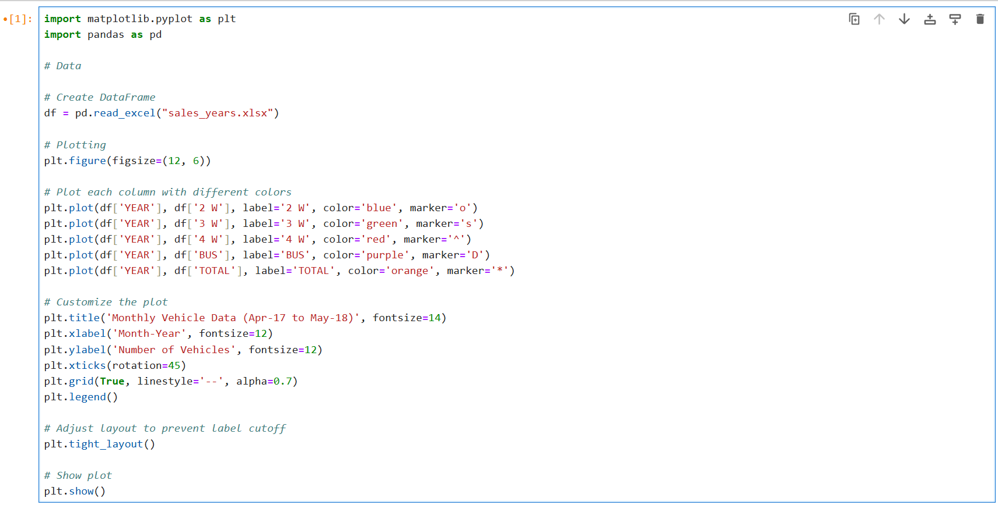

Plot:

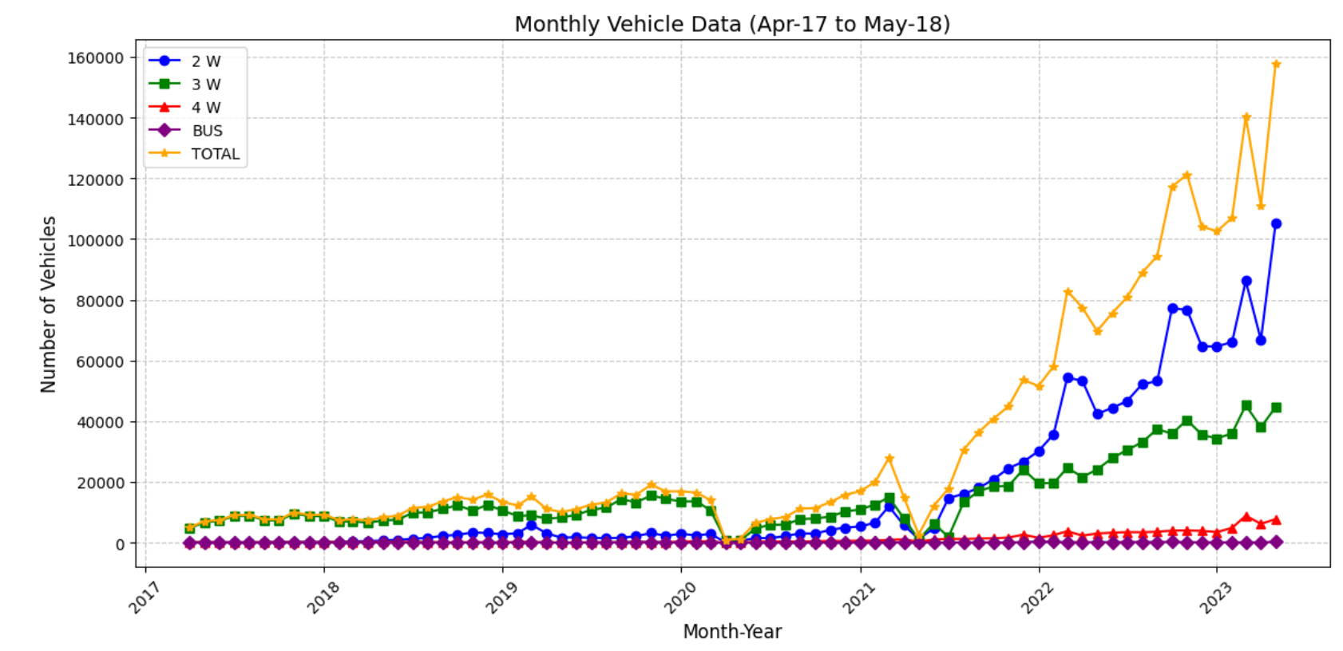

Dataset:

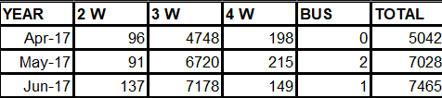   
**….**

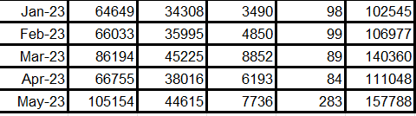

Dataset:

1. **Demographic Dataset:** This dataset contains demographic information.

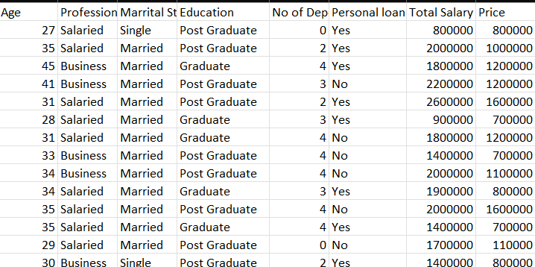

1. Loading the data set and Pre processing:

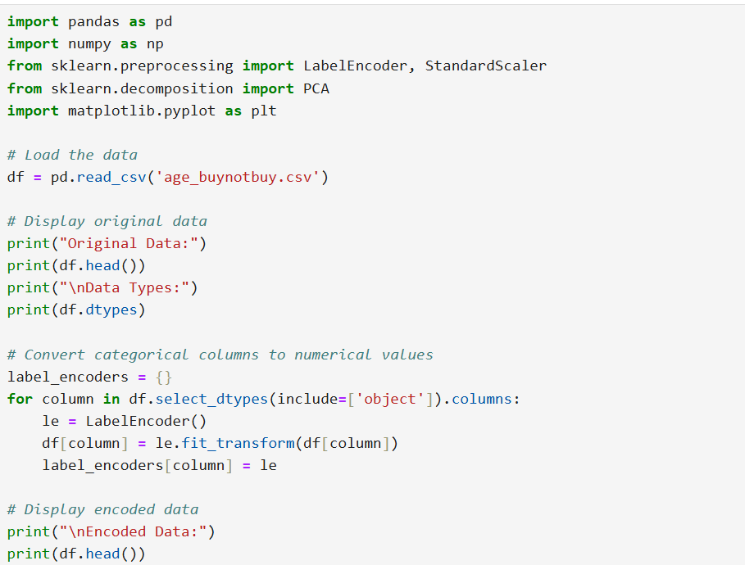

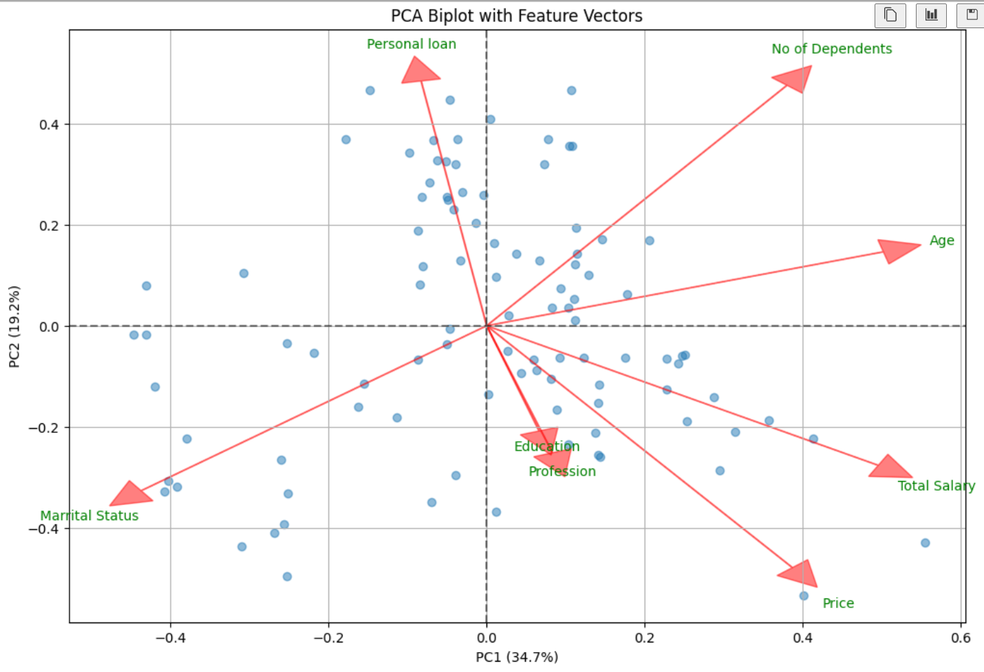

**Inference**: People who are more educated and have profession have “More Salary”.

**2. Behavioural dataset:**

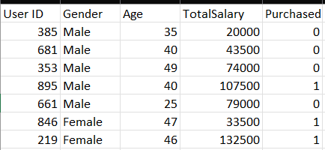  
**……………**

PCA Analysis:

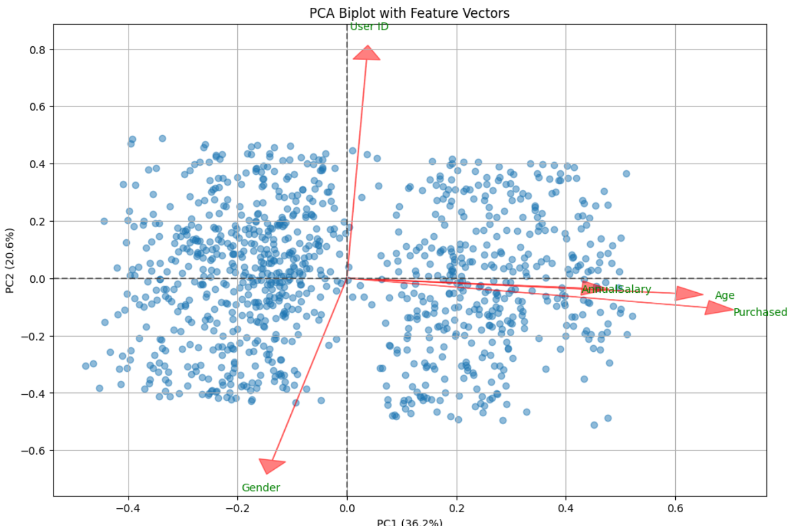

**Inference**: People who have “More Salary” and have “More Age” have more tendency to “**purchase**”.